Question 1:

We are asked to

1. Simulate a small network with switches and multiple devices. Use ping to generate traffic and observe the MAC address table of the switch.
2. Capture packets using Wireshark to analyze Ethernet frames and MAC addressing.

Approach:

* **Simulate a small network with switches and multiple devices. Use ping to generate traffic and observe the MAC address table of the switch.**

The tools I used was cisco packet tracer and wireshark. We are assuming that we got two different questions. Since cisco packet tracer is not an emulator we can’t capture the packet that are transferring inside the V-network. So for the first part we are making a network with 2960 switch and 4 pc with IP address as follow

1. 192.168.11.1
2. 192.168.11.2
3. 192.168.11.3
4. 192.168.11.4

Below I attached the Screen shot of the network with configured PC

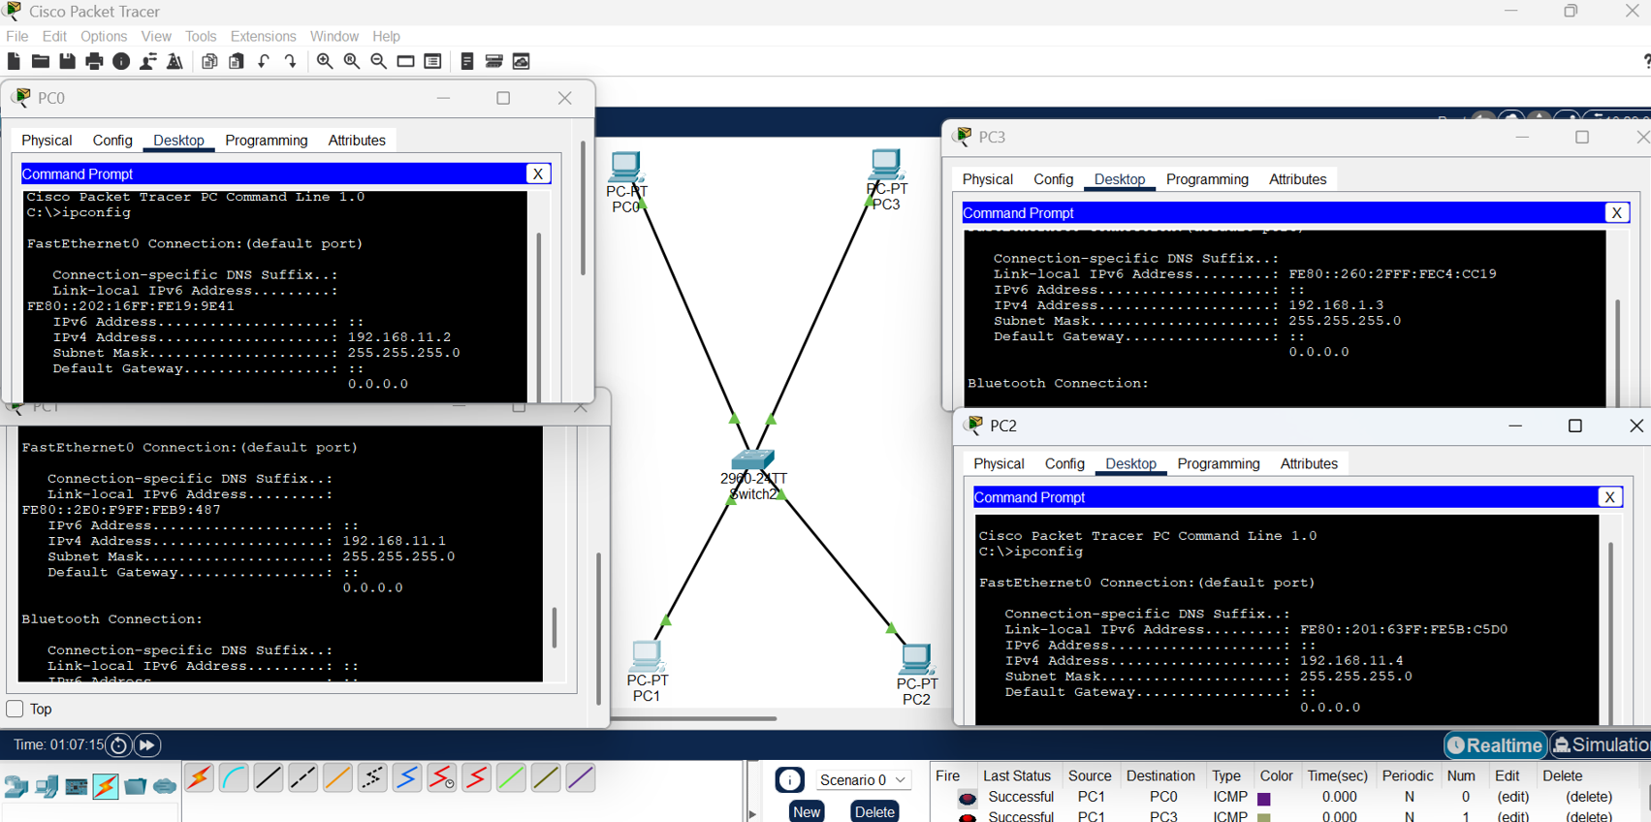

‘Now we are tracing the route of random pc with help of IP address and “tracert” command.

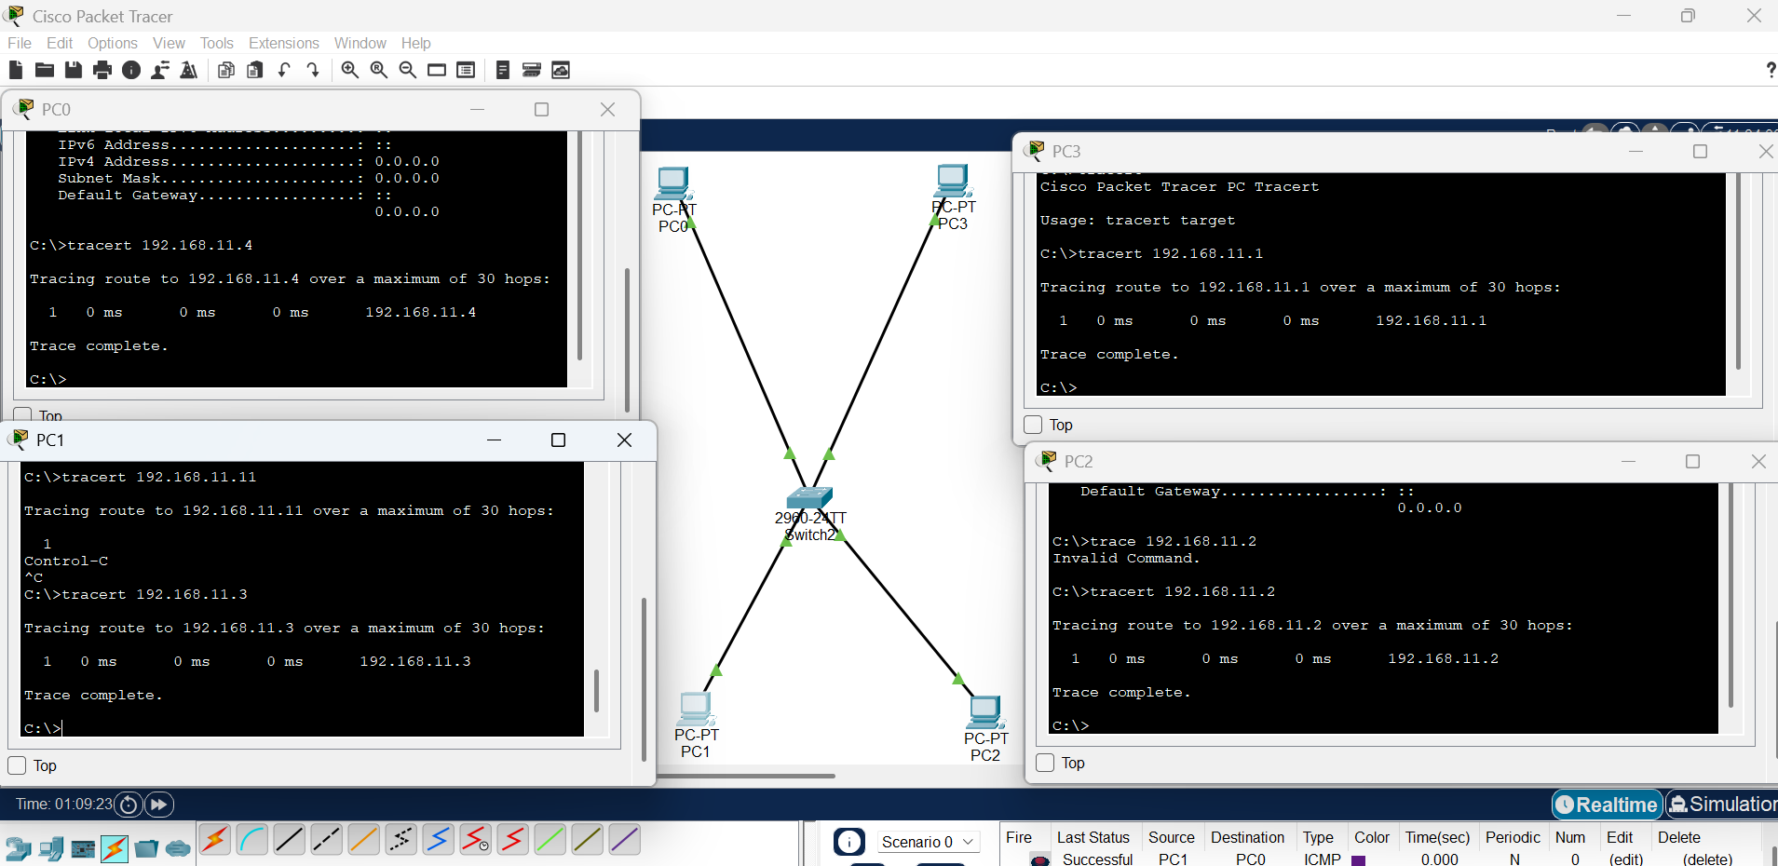

We see a term called hops. It is the number of routers the packet crossed in the network to reach the destination. In this scenario is it 30 just a random number.

Once the route is traced we are using ping command along with Ip address to send ICMP packet to particular PC in the network.

Below is the example of pinging another pc using

**ping -c [no.of ICMP] [IP_ADDR]**

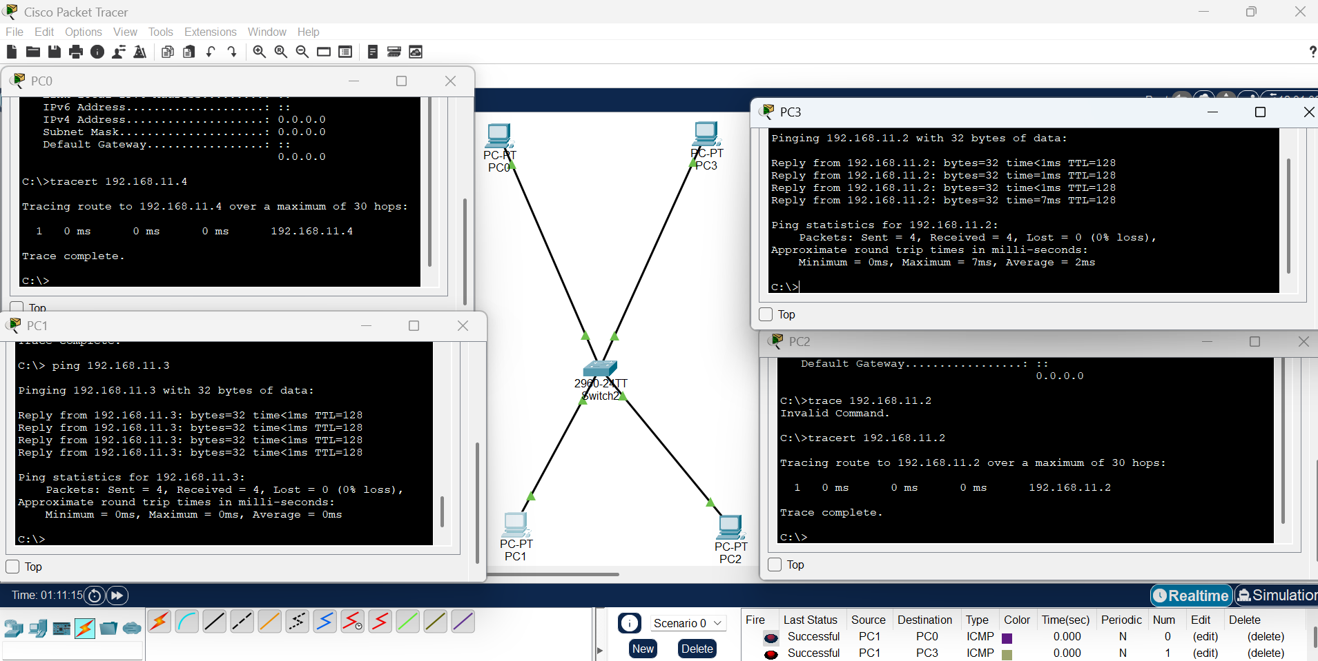

* **Capture packets using Wireshark to analyze Ethernet frames and MAC addressing.**

Here to complete the assignment we are using a virtual machine and local machine. We are going to ping the local machine through virtual machine and trying to capture ICMP packet using wireshark tool

Below is the ping I made from virtual machine to local PC

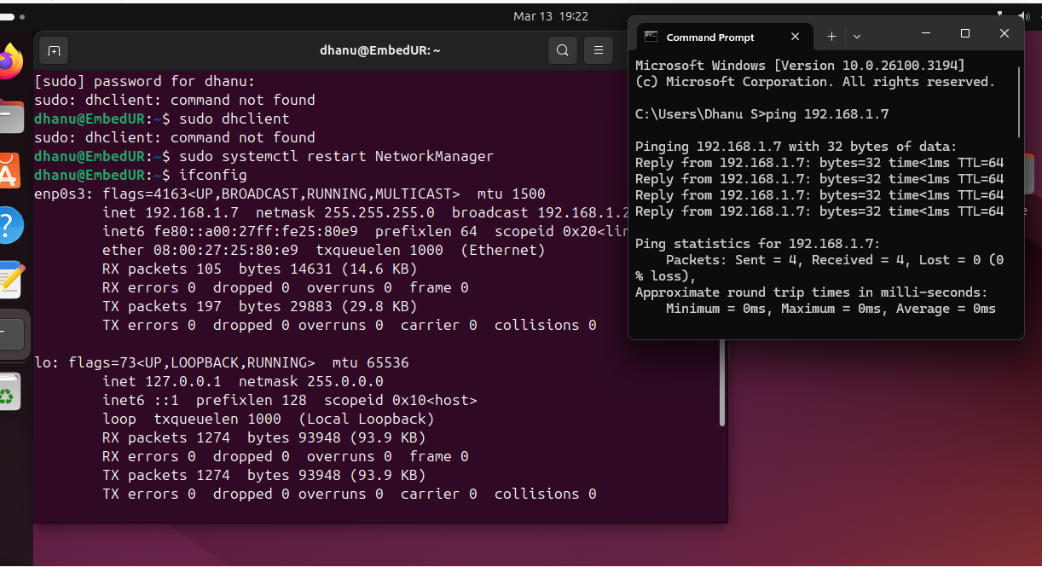

Below is the wireshark packet capture

